ZERO ERROR OF MICROMETER SCREW GAUGE
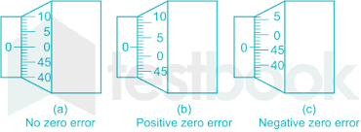

If the zero mark on the rotating/thimble scale is below the datum line, then we have a Positive Zero error.
Count from the zero mark of the rotating scale to the mark on/before the datum line to determine your positive zero error value.
= + 0.03 mm

If the zero mark on the rotating/thimble scale is above the datum line, then we have a Negative Zero error.
Count from the zero mark of the rotating scale to the mark on/before the datum line to determine your positive zero error value.
= - 0.04 mm

http://www.excelatphysics.com/micrometer-screw-gauge.html
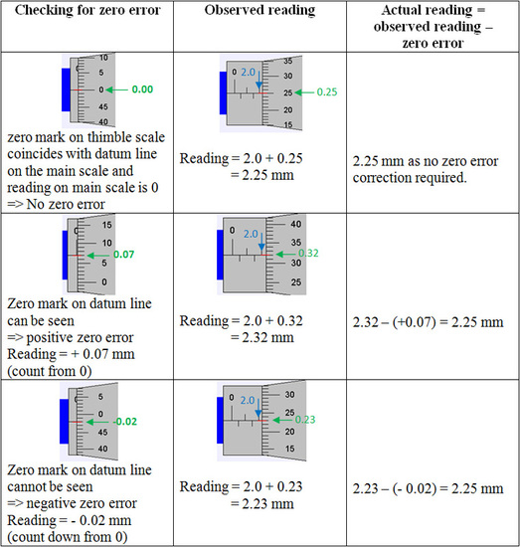
https://www.liveworksheets.com/w/en/physics/830602

